Understanding America’s Federal Budget: Spending, Revenue, and Debt (1980–2024)
The federal budget tells the story of the American economy itself. It shows how the government collects money, spends it, borrows it, and balances competing priorities across generations. Each line in the budget reflects a policy choice that shapes jobs, growth, and the nation’s long-term stability.
Through these visualizations, we explore how U.S. revenues, expenditures, and debt have evolved from 1980 to 2024, revealing key trends that continue to define the country’s fiscal landscape.

The Big Picture: Surplus vs. Deficit
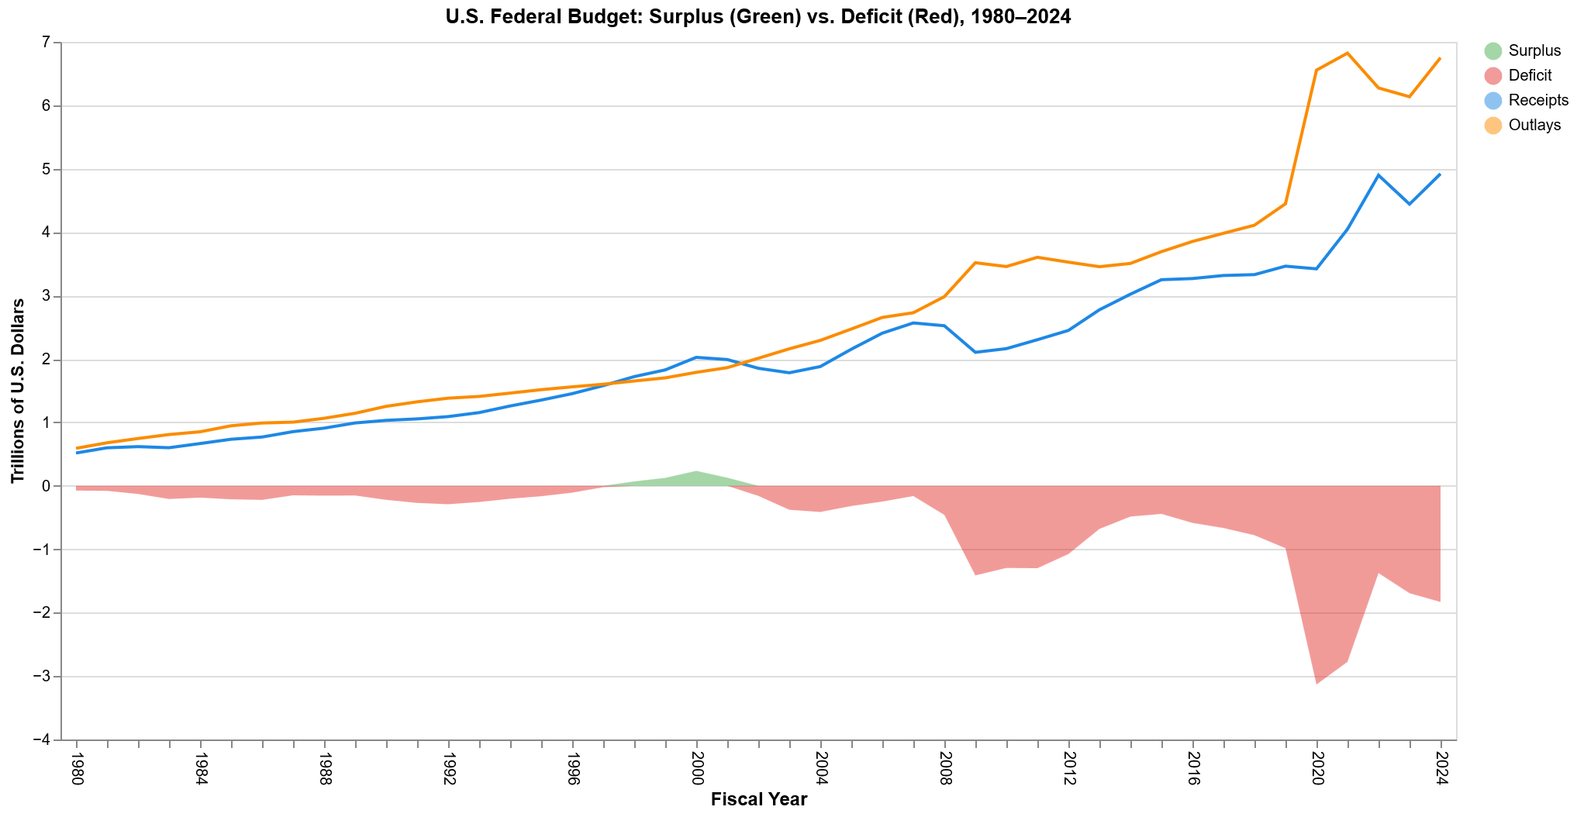
The United States has consistently spent more than it has collected in revenue since the early 2000s, resulting in persistent budget deficits. The first chart compares total receipts (in blue) and outlays (in orange), with the shaded area highlighting the surplus (green) or deficit (red).
After a brief surplus during the late 1990s technology boom, deficits deepened sharply following the 2008 financial crisis and again during the COVID-19 pandemic.
Outlays surged beyond 6 trillion dollars in 2020–2022 as stimulus programs expanded spending, while receipts lagged despite a recovering economy.

Federal Budget Relative to GDP
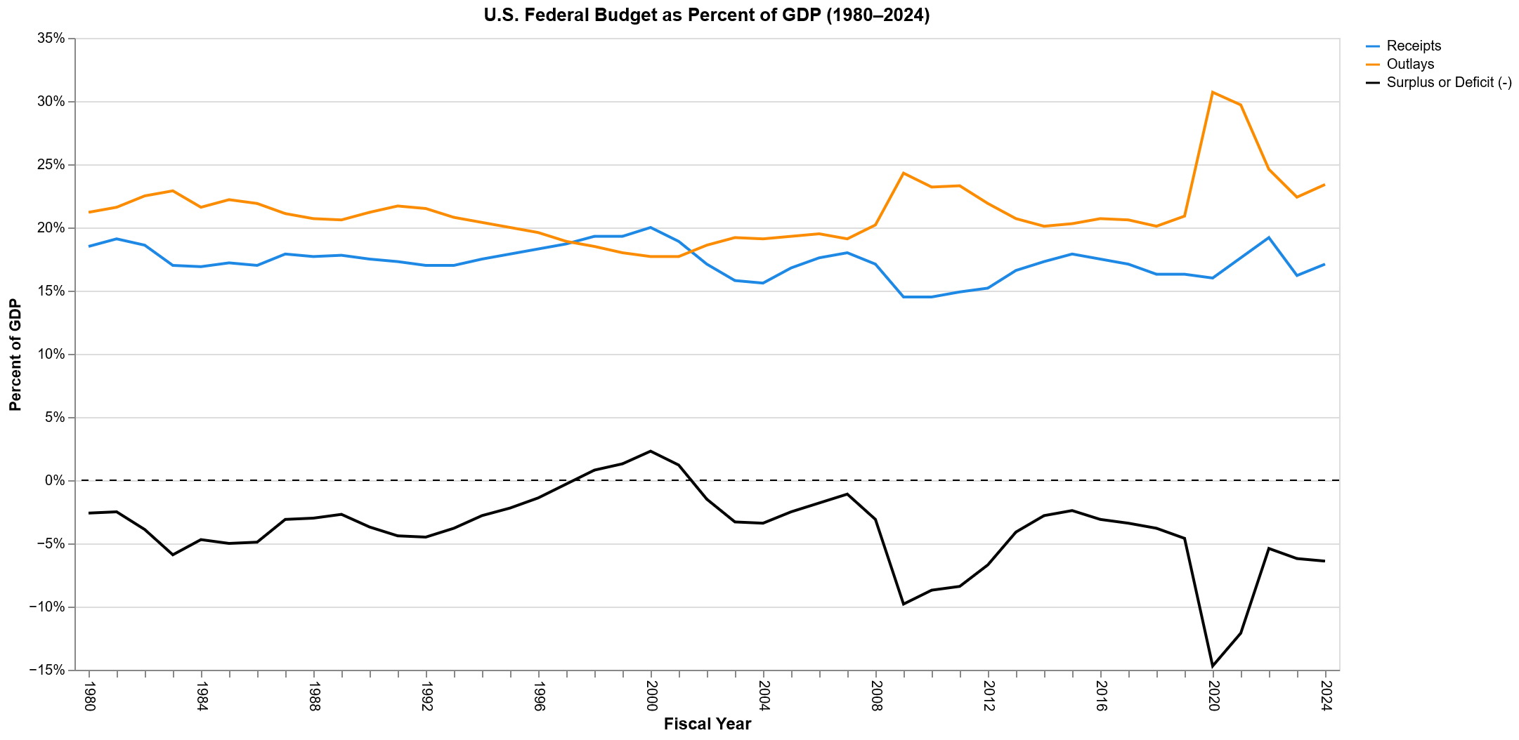
When measured as a share of GDP, the federal budget shows the economy’s capacity to absorb spending.
Receipts have hovered between 15 and 20 percent of GDP, while outlays typically ranged from 20 to 25 percent, except during crisis years when spending spiked above 30 percent.
Deficits therefore averaged around 5 percent of GDP, ballooning to nearly 15 percent in 2020, the largest shortfall since World War II.

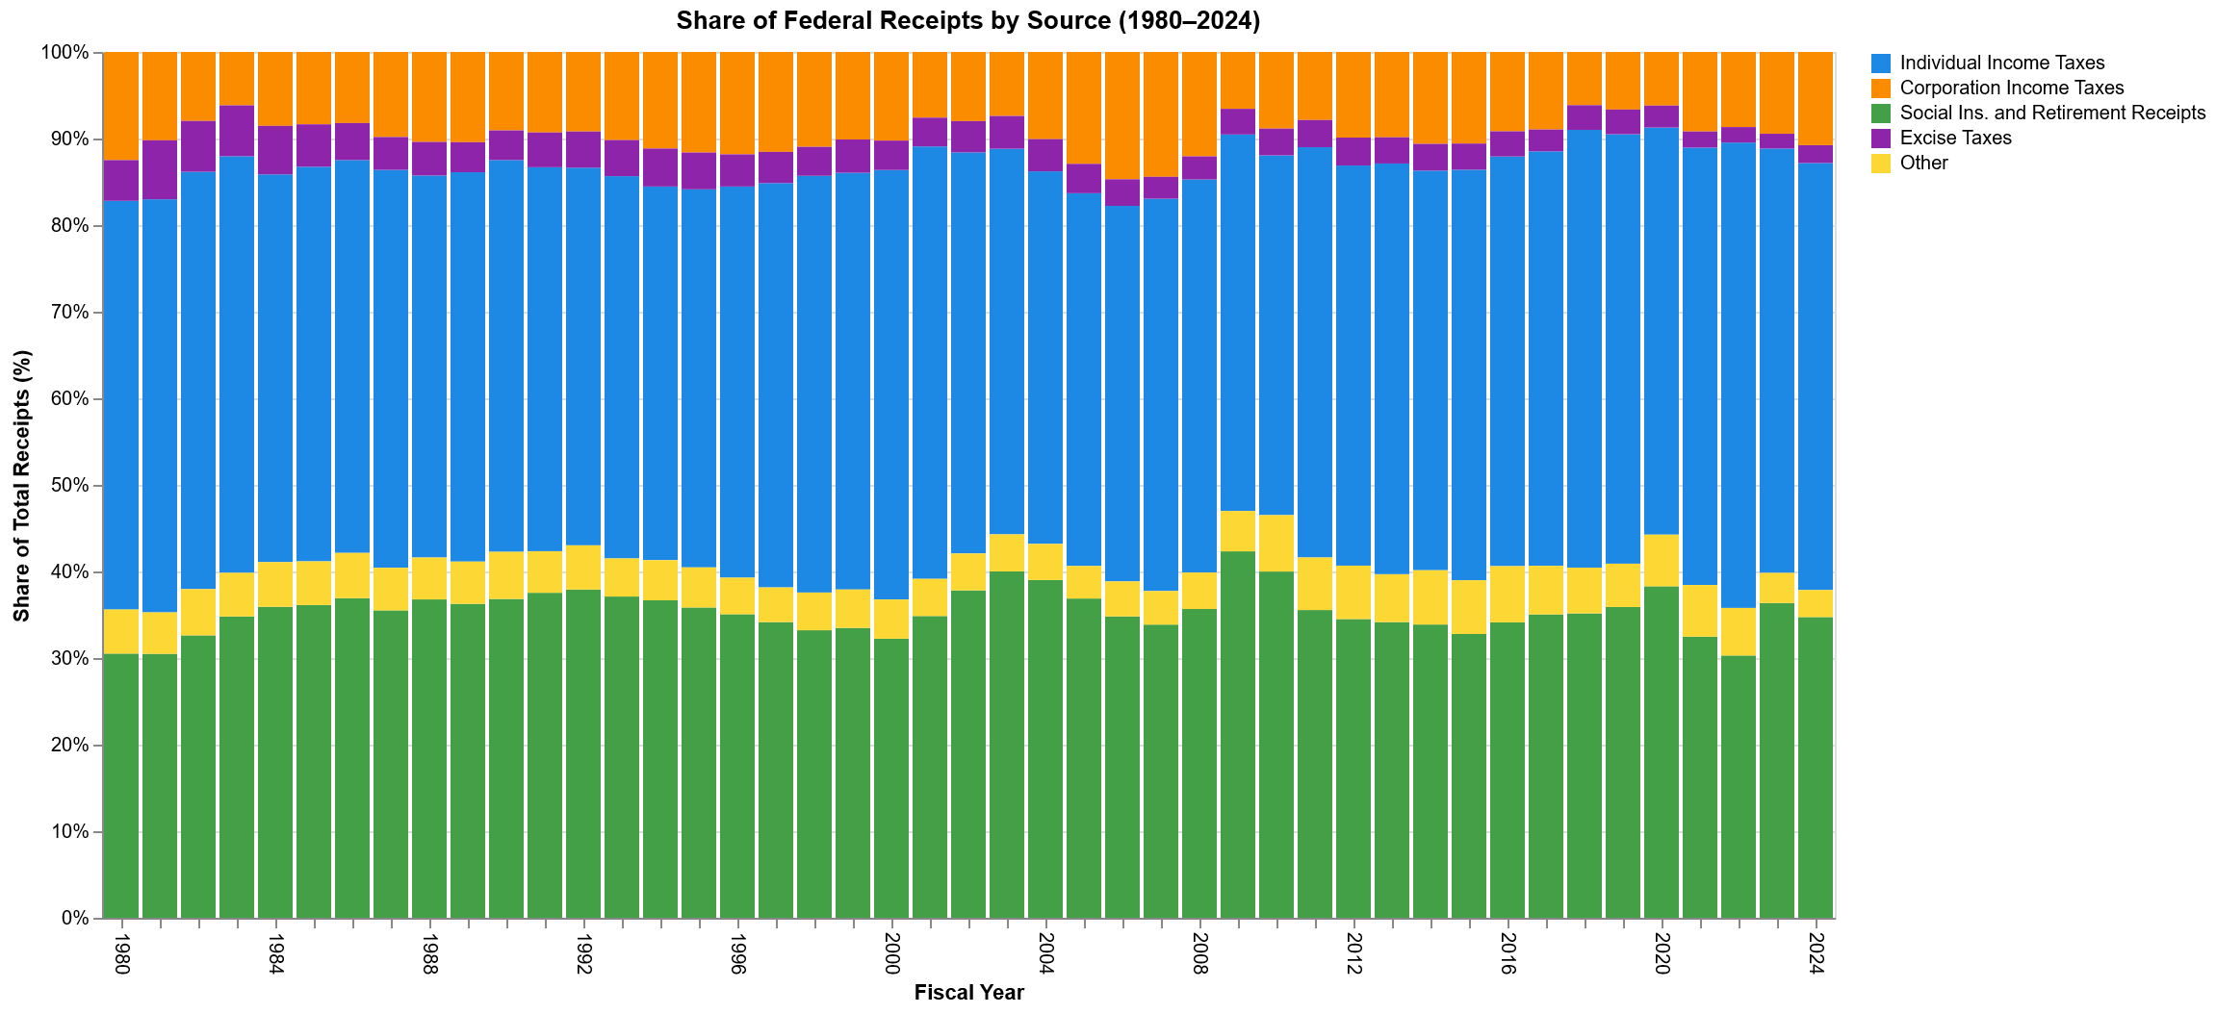
Where the Money Comes From: Receipts by Source
Federal revenues are powered mainly by individual income taxes and social insurance and retirement contributions. Together, they make up roughly 80 percent of all federal receipts.
Over time, corporate income taxes have shrunk as a share of total receipts, while other sources such as excise, customs, and estate taxes contribute only marginally.
Despite fluctuations, the broad structure of U.S. taxation has remained stable. Households, not corporations, provide most of the federal revenue.

Long-Term Shifts in Revenue Composition
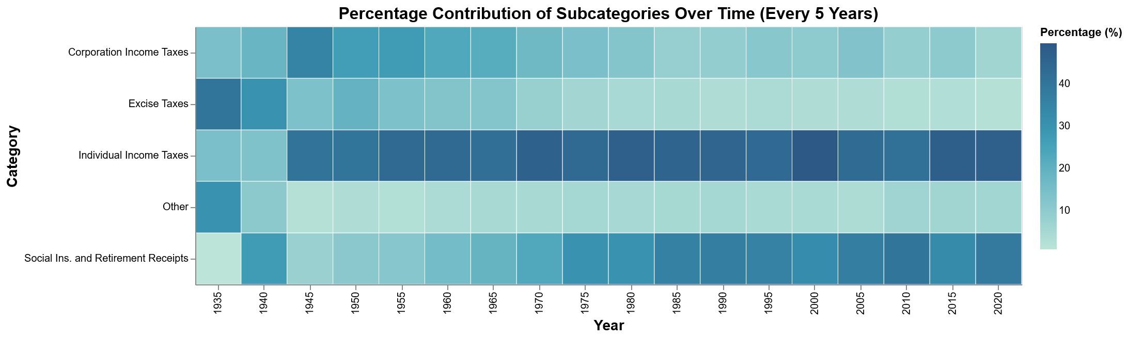
Looking back over eight decades, the heatmap reveals how the balance among revenue sources has evolved.
In the mid-20th century, corporate and excise taxes played larger roles.
By the 1980s and beyond, individual income taxes dominate the federal revenue base, while social insurance contributions such as payroll taxes have steadily risen.
This reflects an aging population and the financing needs of Social Security and Medicare.

How the Money Is Spent: Outlays by Function
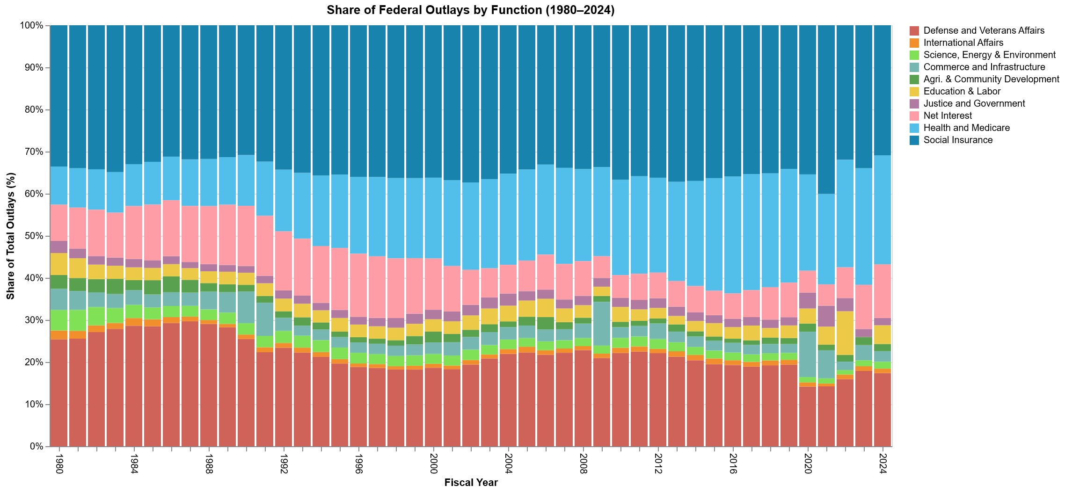
If revenues tell us how the government earns, spending shows what it values. Federal spending priorities have evolved over time. In 1980, Social Insurance programs such as Social Security already accounted for the largest share of total outlays, followed by Health and Medicare. Since then, these categories have continued to expand, while the share devoted to Defense has gradually declined.
Other functions such as education, infrastructure, and international affairs have declined in relative importance.
Meanwhile, interest payments on debt have re-emerged as a growing fiscal pressure.

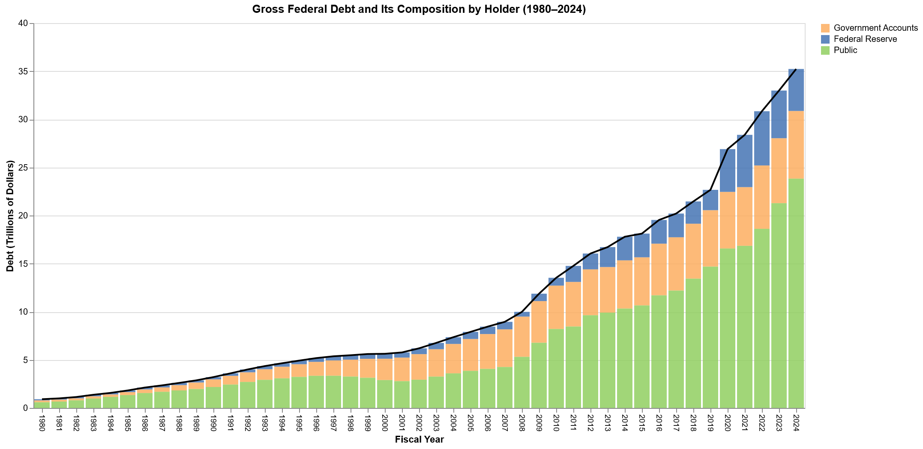
The Rising Tide of Federal Debt
Persistent deficits accumulate into debt. Gross federal debt has risen from less than 1 trillion dollars in 1980 to more than 35 trillion dollars in 2024.
The stacked bars decompose debt held by Government Accounts, the Federal Reserve, and the Public.
Periods of accelerated borrowing align with major recessions and emergency spending in 2008–09 and 2020.
The public’s share has increased substantially, showing how much U.S. debt is now financed through domestic and foreign investors rather than internal trust funds.

Who Owns the Federal Debt (2024 Snapshot)
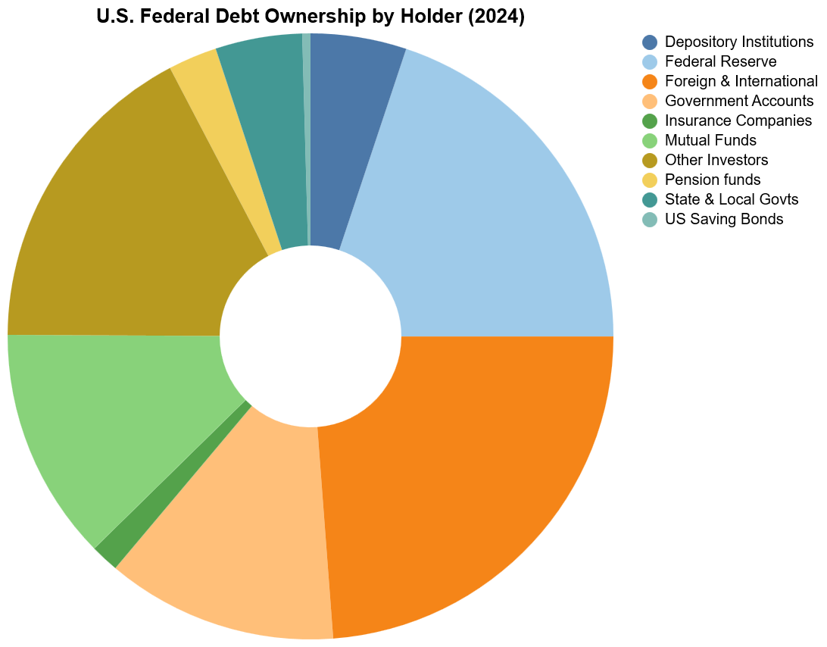
As of 2024, the largest holders of U.S. federal debt include the Federal Reserve, foreign and international investors, and government accounts such as Social Security and federal employee retirement funds.
Mutual funds, pension funds, and insurance companies also play notable roles, linking federal debt directly to the savings of ordinary Americans.
This broad ownership base helps stabilize the Treasury market, although it also means that any fiscal instability affects a wide range of institutions both at home and abroad.

Federal Awards by State
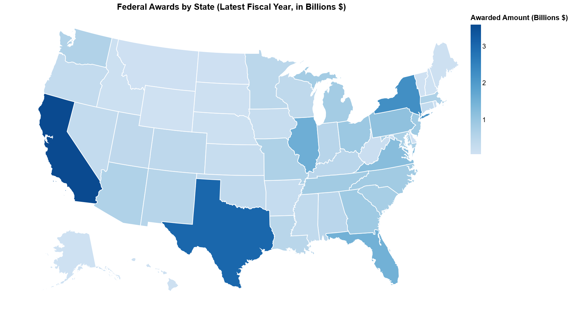
Finally, at the state level, the map illustrates how federal awards and contracts are distributed across the country.
The largest amounts flow to California, Texas, New York, and Florida, reflecting their population size, concentration of industries, and presence of major research and infrastructure projects.
Smaller states generally receive lower totals, though some benefit from strong federal, defense, or technology linkages.

Together, these visualizations show how the federal government’s role in the economy has expanded and transformed over time. They trace the shift from defense-driven spending to programs that support health, income security, and social insurance. They also illustrate how persistent deficits have fueled rising public debt and how the ownership of that debt has diversified across domestic and international holders.

Data Sources
- Office of Management and Budget (OMB). Historical Tables, Budget of the U.S. Government.
Data on federal revenues, outlays, and deficits were obtained from the OMB Historical Tables, available at:
https://www.whitehouse.gov/omb/information-resources/budget/historical-tables/
- U.S. Department of the Treasury, Bureau of the Fiscal Service. Treasury Bulletin – Ownership of Federal Securities.
Data on holders of U.S. Treasury securities were taken from the Treasury Bulletin, available at:
https://www.fiscal.treasury.gov/reports-statements/treasury-bulletin/current.html
- USAspending.gov. State Profiles and Federal Awards Data.
Data on federal contract and award distributions by state were sourced from USAspending’s state-level datasets, available at:
https://www.usaspending.gov/state

